**CMD - Arce Facundo**

***1.***

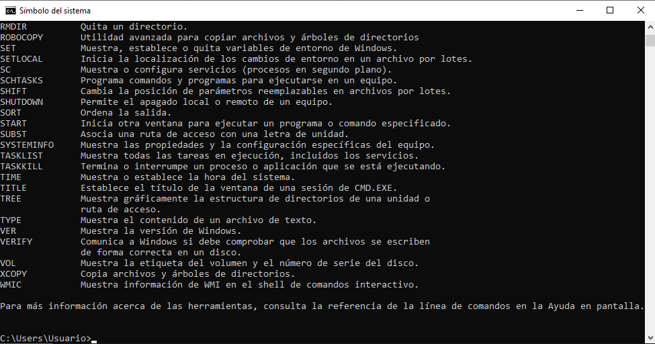

***-------------------------------------------------------------------------------------------------***

***2.***

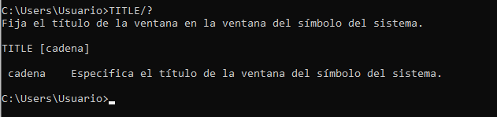

***-------------------------------------------------------------------------------------------------***

***3 y 4.***

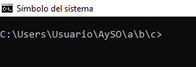

***-------------------------------------------------------------------------------------------------***

***5 6 y 7.***

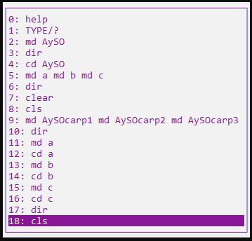

***-------------------------------------------------------------------------------------------------***

***8 y 9.***

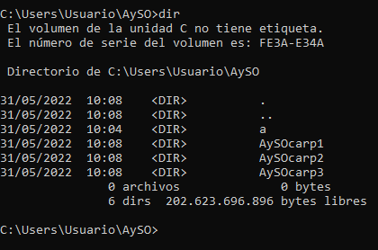

***-------------------------------------------------------------------------------------------------***

***10.***

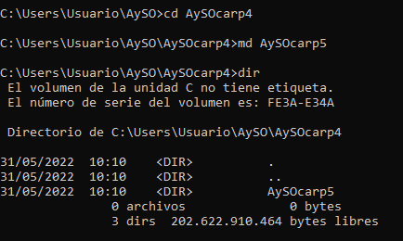

***-------------------------------------------------------------------------------------------------***

***11 y 12.***

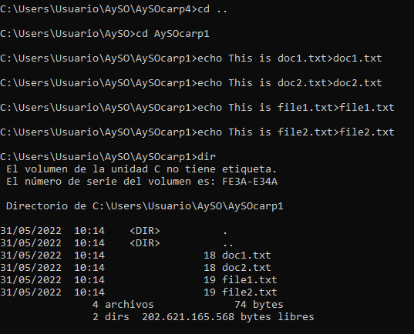

***-------------------------------------------------------------------------------------------------***

***13.***



***-------------------------------------------------------------------------------------------------***

***14.***

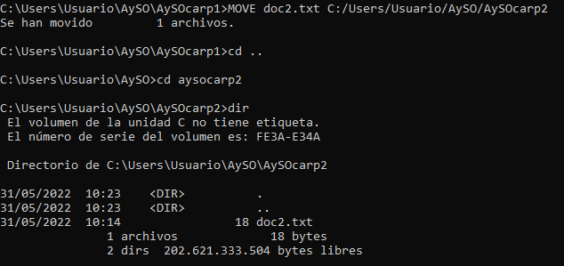

***-------------------------------------------------------------------------------------------------***

***15.***

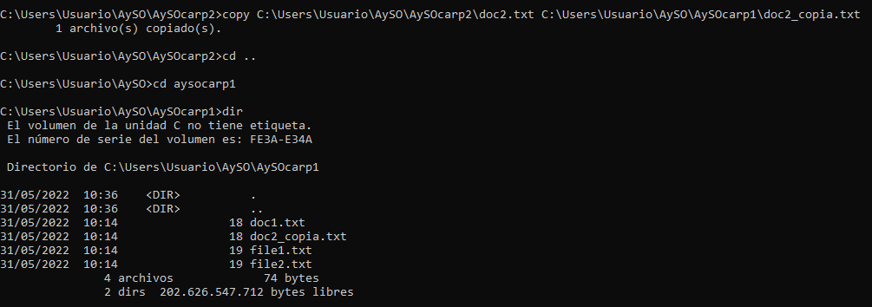

***-------------------------------------------------------------------------------------------------***

***16.***

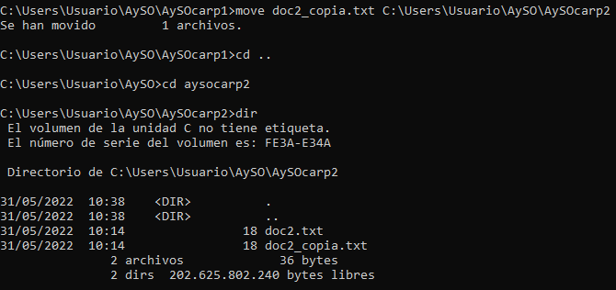

***-------------------------------------------------------------------------------------------------***

***17.***

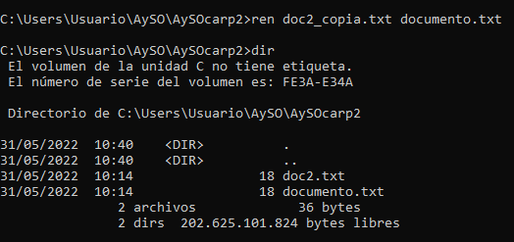

***-------------------------------------------------------------------------------------------------***

***18 y 19.***

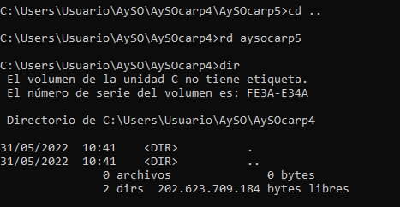

***-------------------------------------------------------------------------------------------------***

***20.***

